**BANK LOAN REPORT QUERY DOCUMENT**

A. BANK LOAN REPORT | SUMMARY -

KPI’S:

Total Loan Applications

Select count(id) as Total_Loan_Application from Bank_Loan_data



MTD Loan Applications

Select count(id) as MTD_Total_Loan_Application from Bank_Loan_data

where month(issue_date) = 12



PMTD Loan Application

Select count(id) as PMTD_Total_Loan_Application from Bank_Loan_data

where month(issue_date) = 11



Total Funded Amount

select sum(loan_amount) as Total_Funded_Amount from Bank_Loan_data



MTD Total Funded Amount

Select sum(loan_amount) as MTD_Total_Funded_Amount from Bank_Loan_data

where month(issue_date)= 12



PMTD Total Funded Amount

Select sum(loan_amount) as MTD_Total_Funded_Amount from Bank_Loan_data

where month(issue_date)= 12



Total Amount Received

select sum(total_payment) as Total_Amount_Received from Bank_Loan_data



MTD Total Amount Received

select sum(total_payment) as MTD_Total_Amount_Received from Bank_Loan_data

where MONTH(issue_date) = 12



PMTD Total Amount Received

select sum(total_payment) as MTD_Total_Amount_Received from Bank_Loan_data

where MONTH(issue_date) = 11



Average Interest Rate

select AVG(int_rate)*100 as Average_Intrest_Rate from Bank_Loan_data



MTD Average Interest

select AVG(int_rate)*100 as Average_Intrest_Rate from Bank_Loan_data

where month(issue_date) = 12



PMTD Average Interest

select AVG(int_rate)*100 as Average_Intrest_Rate from Bank_Loan_data

where month(issue_date) = 11



Avg DTI

select avg(dti)*100 as AVG_DTI from Bank_Loan_data



MTD Avg DTI

select avg(dti)*100 as AVG_DTI from Bank_Loan_data

where month(issue_date) = 12



PMTD Avg DTI

select avg(dti)*100 as AVG_DTI from Bank_Loan_data

where month(issue_date) = 11



GOOD LOAN ISSUED

Good Loan Percentage

select

(count(case when loan_status = 'Fully Paid' or loan_status = 'Current' then id end) * 100.0) /

count(id) as Good_Loan_Percentage

from Bank_Loan_data



Good Loan Application

select count(id) as Good_loan_application from Bank_Loan_data

where loan_status = 'Fully Paid' OR loan_status = 'Current'



Good Loan Funded Amount

select sum(loan_amount) as Good_Loan_Funded_amount from Bank_Loan_data

where loan_status = 'Fully Paid' OR loan_status = 'Current'



Good Loan Amount Received

select sum(total_payment) as Good_Loan_amount_Received from Bank_Loan_data

where loan_status = 'Fully Paid' OR loan_status = 'Current'



BAD LOAN ISSUED

Bad Loan Percentage

select

(count(case when loan_status = 'Charged off' then id end) * 100.0) /

count(id) as Bad_loan_Percentage

from Bank_Loan_data



Bad Loan Application

select count(id) as Bad_loan_application from Bank_Loan_data

where loan_status = 'Charged off'



Bad Loan Application

select sum(loan_amount) as Bad_Loan_Funded_amount from Bank_Loan_data

where loan_status = 'Charged off'



Bad Loan Amount Received

select sum(total_payment) as Bad_Loan_amount_Received from Bank_Loan_data

where loan_status = 'Charged off'



LOAN STATUS

select

loan_status,

count(id) as Loan_Count,

sum(Loan_amount) AS Total_Funded_Amount,

sum(total_payment) as total_Amount_Received,

AVG(int_rate)*100 as Interest_rate,

Avg(dti)*100 as DTI

from Bank_Loan_data

group by loan_status

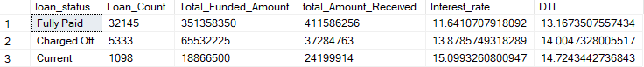

select

loan_status,

count(id) as MTD_Loan_Count,

sum(Loan_amount) AS MTD_Total_Funded_Amount,

sum(total_payment) as MTD_total_Amount_Received,

AVG(int_rate)*100 as MTD_Interest_rate,

Avg(dti)*100 as MTD_DTI

from Bank_Loan_data

where month(issue_date) = 12

group by loan_status



select

loan_status,

count(id) as PMTD_Loan_Count,

sum(Loan_amount) AS PMTD_Total_Funded_Amount,

sum(total_payment) as PMTD_total_Amount_Received,

AVG(int_rate)*100 as PMTD_Interest_rate,

Avg(dti)*100 as PMTD_DTI

from Bank_Loan_data

where month(issue_date) = 11

group by loan_status



B. BANK LOAN REPORT | OVERVIEW

MONTH

select

month(issue_date) as Month_number,

Datename(month,issue_date) as Month_name,

count(id) as Total_Loan_Application,

sum(Loan_amount) as Total_Amount_Funded,

sum(total_payment) as Total_Amount_recived

from Bank_Loan_data

group by month(issue_date), Datename(month,issue_date)

order by month(issue_date)

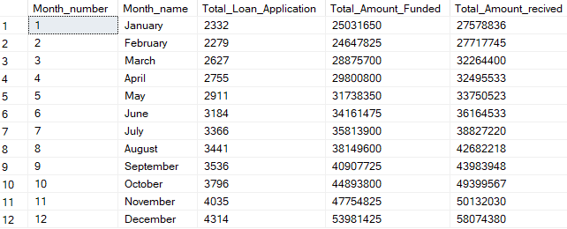

STATE

select

address_state as State,

COUNT(id) as Total_Loan_Applications,

sum(Loan_amount) as Total_Amount_Funded,

sum(total_payment) as Total_Amount_recived

from Bank_Loan_data

group by address_state

order by address_state

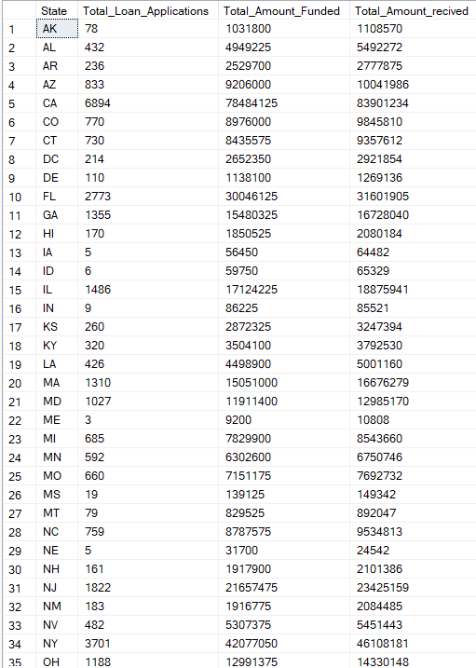

TERM

Select

term as Term,

COUNT(id) as Total_Loan_Applications,

sum(Loan_amount) as Total_Amount_Funded,

sum(total_payment) as Total_Amount_recived

from Bank_Loan_data

group by term

order by Term



EMPLOYEE LENGTH

Select

emp_length as Employee_Length,

COUNT(id) as Total_Loan_Applications,

sum(Loan_amount) as Total_Amount_Funded,

sum(total_payment) as Total_Amount_recived

from Bank_Loan_data

group by emp_length

order by emp_length

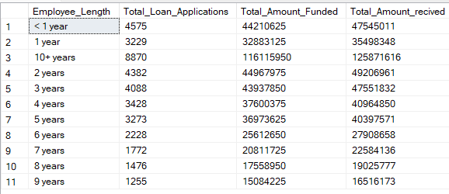

PURPOSE

select

purpose as purpose,

COUNT(id) as Total_Loan_Applications,

sum(Loan_amount) as Total_Amount_Funded,

sum(total_payment) as Total_Amount_recived

from Bank_Loan_data

group by purpose

order by purpose

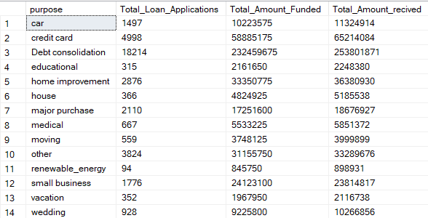

HOME OWNERSHIP

select

home_ownership as Home_Ownership,

COUNT(id) as Total_Loan_Applications,

sum(Loan_amount) as Total_Amount_Funded,

sum(total_payment) as Total_Amount_recived

from Bank_Loan_data

group by home_ownership

order by Home_Ownership

